 

# DESIGN AND FABRICATION OF A COMPACTABLE WATER PUMP

**A PROJECT REPORT**

***Submittedby***

***BALAKRISHNAN.R (927622BME006)***

***BENNY THOMAS.A (927622BME007)***

***BHARANIDHARAN.M (927622BME008)***

***In partialfulfillment for the award of the degree***

***of***

BACHELOR OF ENGINEERING

**IN**

# MECHANICALENGINEERING

**M.KUMARASAMYCOLLEGEOFENGINEERING,KARUR**

ANNAUNIVERSITY:CHENNAI60002

# 

# May - 2024

**M.KUMARASAMY COLLEGE OF ENGINEERING,KARUR**

**ANNA UNIVERSITY : CHENNAI 600 025**

**BONAFIDE CERTIFICATE**

Certified that this project report **“FABRICATION OF COMPACT WATER PUMP”** is the bonafidework of**BALAKRISHNAN.R(927622BME006), BENNYTHOMAS.A(927622BME007), BHARANIDHARAN.M (927622BME008)** who carried out the project work during the academic year 2023 – 2024 under my supervision. Certified further, that to the best of my knowledge the work reported herein does not form part of any other project report or dissertation on the basis of which a degree or award was conferred on an earlier occasion on this or any other candidate.

**SIGNATURE SIGNATURE**

Dr. M. LOGANATHAN M.E., Ph.D. Dr. G.R.GOPINATH M.E., Ph.D.

**HEAD OF THE DEPARTMENT SUPERVISOR**

Department of Mechanical Engineering, Department of Mechanical Engineering

M.Kumarasamy College of engineering M.Kumarasamy College of Engineering

Thalavapalayam, Karur-639113. Thalavapalayam, Karur-639113

This project report has been submitted for the end semester project viva voce Examination held on ______________

INTERNAL EXAMINER EXTERNAL EXAMINER

**DECLARATION**

We affirm that the Project titled “ **FABRICATION OF COMPACT WATER PUMP**” being submitted in partial fulfillment for the award of Bachelor of Engineering in Mechanical Engineering, is the original work carried out by us. It has not formed the part of any other project or dissertation on the basis of which a degree or award was conferred on an earlier occasion on this or any other candidate.

Student name Signature

1 R.BALAKRISHNAN _______________________

2 A.BENNY THOMAS _______________________

3 M.BHARANIDHARAN _______________________

Name and signature of the supervisor with date

**ACKNOWLEDGEMENT**

Our sincere thanks to Thiru. M. Kumarasamy, founder and Dr. K. RAMAKRISHNAN B.E, Chairman of M. Kumarasamy College of Engineering for providing extra ordinary infrastructure, which helped us to complete the project in time.

It is a great privilege for us to express our gratitude to our esteemed Principal Dr.B.S. MURUGAN M.E., Ph.D. for providing us right ambiance for carrying out the project work.

We would like to thank Dr. M. LOGANATHAN M.E, Ph.D, Head, Department of Mechanical Engineering, for their unwavering moral support throughout the evolution of the project.

We offer our whole hearted thanks to our internal guide Dr. G.R.GOPINATH M.E., Ph.D., Assistant Professor, Department of Mechanical Engineering, for his constant encouragement, kind co-operation, valuable suggestions and support rendered in making our project a success.

We offer our whole hearted thanks to our project coordinator Dr. H.VINOTH KUMAR M.E.,Ph.D Department of Mechanical Engineering, for his constant encouragement, kind co-operation, valuable suggestions and support rendered in making our project a success.

We glad to thank all the Teaching and Non-Teaching Faculty Members of Department of Mechanical Engineering for extending a warm helping hand and valuable suggestions throughout the project.

Words are boundless to thank Our Parents and Friends for their constant encouragement to complete this project successfully.

**INSTITUTION VISION & MISSION**

**Vision:**

* To emerge as a leader among the top institutions in the field of technical education.

**Mission:**

* Produce smart technocrats with empirical knowledge who can surmount the global challenges.
* Create a diverse, fully-engaged, learner-centric campus environment to provide quality educationϖ to the students.
* Maintain mutually beneficial partnerships with our alumni, industry and professional associations.

**DEPARTMENT VISION, MISSION, PEO, PO & PSO**

**VISION:**

* To create globally recognized competent Mechanical engineers to work in multiculturalϖ environment.

**Mission :**

* To impart quality education in the field of mechanical engineering and to enhance their skills, to pursue careers or enter into higher education in their area of interest.
* To establish a learner-centric atmosphere along with state-of-the-art research facility.
* To make collaboration with industries, distinguished research institution and to become a centre ofϖ excellence

**PROGRAM EDUCATIONAL OBJECTIVES (PEOS)**

The graduates of Mechanical Engineering will be able to

* PEO1: Graduates of the program will accommodate insightful information of engineering principles necessary for the applications of engineering.
* PEO2: Graduates of the program will acquire knowledge of recent trends in technology and solve problem in industry.
* PEO3: Graduates of the program will have practical experience and interpersonal skills to work both in local and international environments.
* PEO4: Graduates of the program will possess creative professionalism, understand their ethical responsibility and committed towards society.

**PROGRAM OUTCOMES**

**The following are the Program Outcomes of**

**Engineering Graduates: Engineering Graduates will**

**be able to:**

**1.Engineering knowledge: Apply the knowledge of mathematics, science, engineering fundamentals, and an engineering specialization to the solution of complex engineering problems.**

**2.Problem analysis:** Identify, formulate, review research literature, and analyze complex engineering problems reaching substantiated conclusions using first principles of mathematics, natural sciences, and engineering sciences.

**3.Design/development of solutions:** Design solutions for complex engineering problems and design system components or processes that meet the specified needs with appropriate consideration for the public health and safety, and the cultural, societal, and environmental considerations.

**4.Conduct investigations of complex problems:** Use research-based knowledge and research methods including design of experiments, analysis and interpretation of data, and synthesis of the information to provide valid conclusions.

**5.Modern tool usage:** Create, select, and apply appropriate techniques, resources, and modern engineering and IT tools including prediction and modeling to complex engineering activities with an understanding of the limitations.

**6**. **The engineer and society:** Apply reasoning informed by the contextual knowledge to assess societal, health, safety, legal and cultural issues and the consequent responsibilities relevant to the professional engineering practice.

**7**. **Environment and sustainability:** Understand the impact of the professional engineering solutions in societal and environmental contexts, and demonstrate the knowledge of, and need for sustainable development.

**8.Ethics:** Apply ethical principles and commit to professional ethics and responsibilities and norms of the engineering practice.

**9**. **Individual and team work:** Function effectively as an individual, and as a member or leader in diverse teams, and in multidisciplinary settings.

**10.Communication:** Communicate effectively on complex engineering activities with the engineering community and with society at large, such as, being able to comprehend and write effective reports and design documentation, make effective presentations, and give and receive clear instructions. effective reports and design documentation, make effective presentations, and give and receive clear instructions.

**11.Project management and finance:** Demonstrate knowledge and understanding of the engineering and management principles and apply these to one’s own work, as a member and leader in a team, to manage projects and in multidisciplinary environments. 12. Life-long learning: Recognize the need for, and have the preparation and ability to engage in independent and life-long learning in the broadest context of 13. technological change.

**12. Life-long learning:** Recognize the need for, and have the preparation and ability to engage in independent and life-long learning in the broadest context of technological change.

**PROGRAM SPECIFIC OUTCOMES (PSOs)**

The following are the Program Specific Outcomes of Engineering .

**Graduates:** The students will demonstrate the abilities

**1. Real world application:** To comprehend, analyze, design and develop innovative products and provide solutions for the real-life problems.

**2. Multi-disciplinary areas:** To work collaboratively on multi-disciplinary areas and make quality projects.

R**esearch oriented innovative ideas and methods:** To adopt modern tools, mathematical, scientific and engineering fundamentals required to solve industrial and societal problems

|  |  |  |  |  |  |  |  |  |  |  |  |  |  |  |
| --- | --- | --- | --- | --- | --- | --- | --- | --- | --- | --- | --- | --- | --- | --- |
|  | ProgramOutcomes | | | | | | | | | | | ProgramSpecificOutcomes | | |
| 1 | 2 | 3 | 4 | 6 | 7 | 8 | 9 | 10 | 11 | 12 | 1 | 2 | 3 |
| CO-1 | 3 | 3 | 3 | 3 | 2 | 2 | 2 | 2 | 3 | 2 | 2 | 1 | 2 | 3 |
| CO-2 | 3 | 3 | 3 | 3 | 2 | 2 | 2 | 2 | 3 | 2 | 2 | 1 | 2 | 3 |
| CO-3 | 3 | 3 | 3 | 3 | 2 | 2 | 2 | 2 | 3 | 2 | 2 | 1 | 2 | 3 |
| CO-4 | 3 | 3 | 3 | 3 | 2 | 2 | 2 | 2 | 3 | 2 | 2 | 1 | 2 | 3 |
| CO-5 | 3 | 3 | 3 | 3 | 2 | 2 | 2 | 2 | 3 | 2 | 2 | 1 | 2 | 3 |

**CONTENTS**

|  |  |  |
| --- | --- | --- |
| **CHAPTER NO** | **TITLE** | **PAGE. NO** |
| 1 | ABSTRACT | 1 |
| 2 | INTRODUCTION | 2 |
| 3 | LITERATURE REVIEW | 4 |
| 4 | MATERIALS AND METHODS |  |
|  | LIST OF MATERIALS | 7 |
| 5  6 | WORKING PRINCIPLE  PHOTOGRAPHS | 20  30 |
| 7 | ADVANTAGES, DIS-ADVANTAGES AND  APPLICATION | 22 |
| 8 | CONCLUSION AND FUTURE SCOPE | 25 |
| 9 | REFERENCE | 26 |

**LIST OF FIGURE**

|  |  |  |
| --- | --- | --- |
| Fig.No | Figure Name | Page No |
| Fig 4.1 | Metal strip | 18 |
| Fig 4.2 | Solar panel | 19 |
| Fig 4.3 | D.C.Motor | 20 |
| Fig 4.4 | Battery | 21 |
| Fig 4.5 | Shaft | 25 |
| Fig 4.6 | P.V.C.Pipe | 26 |
| Fig 4.7 | Ball bearing | 27 |
| Fig 4.8 | Disc | 28 |
| Fig 4.9 | Frame | 29 |

Fig 5.1 2D Diagram 30

Fig 6.1 Photograph 31

Fig 6.2 Photograph 31

**CHAPTER 1**

**ABSTRACT**

In response to the pressing global challenge of water scarcity and the need for sustainable agricultural practices, this project proposes the design and implementation of a solar-powered water pump system. Traditional water pumping methods often rely on non-renewable energy sources, contributing to environmental degradation and exacerbating resource depletion. In contrast, our proposed system harnesses solar energy to pump water for agricultural irrigation, offering a renewable and environmentally friendly solution.

The project aims to address several key objectives, including the design and construction of a robust solar-powered water pump, integration with existing irrigation infrastructure, optimization of system efficiency, and evaluation of its impact on agricultural productivity and resource conservation. Through the utilization of solar panels, energy storage systems, and efficient pump mechanisms, the proposed system seeks to provide reliable water access to farmers while minimizing reliance on grid electricity or fossil fuels.

Furthermore, the project emphasizes community engagement and capacity-building efforts to ensure the successful adoption and long-term sustainability of the solar water pump system. Collaboration with local stakeholders, including farmers, technicians, and policymakers, will facilitate knowledge exchange, training, and the establishment of maintenance protocols to support the continued operation of the system.

Ultimately, this project endeavors to contribute to the advancement of sustainable agriculture practices by harnessing solar energy to address water scarcity challenges, promote resilience in rural communities, and mitigate the environmental impact of traditional water pumping methods.

**CHAPTER 2**

**INTRODUCTION**

This report will detail the process of designing and building the solar water pump with bottle caps. It will include the materials needed, step-by-step assembly instructions, and the scientific principles behind the pump's operation. Additionally, we will discuss the practical applications and benefits of this technology, especially in areas with limited resources.

Access to reliable and sustainable water sources is a significant challenge in many rural and off-grid regions worldwide. Traditional water pumping systems, which often rely on grid electricity or diesel generators, are not only expensive but also contribute to environmental degradation. Addressing these issues, this project explores an innovative approach by developing a solar-powered water pump using readily available materials, specifically bottle caps.

The core idea behind this project is to create an accessible and cost-effective solution for water pumping that can be easily replicated and maintained using common household items. By harnessing solar energy through photovoltaic (PV) panels, the system converts sunlight into electricity to power a water pump constructed primarily from bottle caps and other recyclable materials. This method not only reduces dependency on non-renewable energy sources but also promotes environmental sustainability through the reuse of waste materials.

The key components of the system include PV panels to capture solar energy, a battery for energy storage, and a custom-built water pump made from bottle caps. The innovative use of bottle caps serves as the primary construction material for the pump mechanism, showcasing a creative approach to resource utilization and waste reduction.

This project aims to demonstrate the feasibility and effectiveness of a low-cost, solar-powered water pump system that can be easily assembled and maintained by communities with limited resources. By improving water accessibility for irrigation, livestock, and household needs, this system has the potential to enhance agricultural productivity and support sustainable livelihoods. This introduction outlines the motivation, objectives, and anticipated benefits of implementing a solar-powered water pump using bottle caps, setting the stage for a detailed exploration of its design, functionality, and impact on rural water management.

Critical to this system's functionality are the PV panels for solar energy capture and conversion, alongside a battery unit for energy storage. The ingenuity of utilizing bottle caps for the pump construction underscores a commitment to resourcefulness and waste reduction, embodying a grassroots approach to technological innovation.This introduction sets the stage for an in-depth exploration of the system's design, implementation, and anticipated impact on rural water management. this report will provide an overview of the solar water pump project, demonstrating how bottle caps can be transformed into a useful device powered by solar energy. This project contributes to water conservation, reduces plastic waste, and showcases the power of innovative thinking in promoting sustainability.

**CHAPTER 3**

**LITERATURE REVIEW**

Jadhav Hitesh Ramesh, Dhamapurkar Mahesh Mahadev, SakreVirajVivek

DESIGN AND FABRICATION OF WATER PUMPING USING WIND POWER

Water pumping using wind power is an innovative and sustainable method of accessing clean water in remote locations. This approach involves harnessing the power of wind turbines to drive water pumps, which can then be used for irrigation, livestock watering, and domestic consumption. The abstract of the topic focuses on the various benefits of using wind power for water pumping, such as reducing carbon emissions, minimizing operational costs, and promoting local economic development. The abstract also explores the challenges and limitations of this approach, including issues related to wind variability, maintenance, and initial investment costs. Overall, the abstract emphasizes the importance of integrating renewable energy technologies into water management strategies, particularly in regions where access to water is limited

# Bright Samson

# Design of A Small Scale Solar Powered Water Pumping System

An intense irradiation by the sun on the earth causes excessive evapotranspiration (loss of water), a factor that is unpleasant to farmlands, livestock and remote areas where people reside. This unpleasant situation can be used as an opportunity to provide enormous supply of water to these areas.

This work focuses on the design; fabrication and testing of water pump system powered by a solar photovoltaic (P.V) panel. Two 12V, 17AH battery was incorporated in the pump system to ensure storage and stability of power discharged. The system pumped water at an average of 30L/min within the hours of 1pm to 4pm at an hour interval. The pump was operated at different heads ranging from 3m to 10m. The pump performed with an efficiency of 3.94% to 13.14%. The power consumption was fixed at 0.373kWh. The design and testing of the solar pump are presented in this work. The design can be used in rural and semi-urban areas with a moderate populationand farms for irrigation practices where grid electricity is unavailable.

Priyanka , V. Raghavendra , Vijaykumar Palled and M. Veerangouda

Performance Evaluation of Solar Water Pumping System

The use of photovoltaic (PV) array for pumping water is one of the most promising techniques in solar energy applications. In this paper design and performance analyze of solar water pumping system is presented for college of Agricultural engineers UAS campus conditions. The solar pumping system consists of 32 modules of 255.8 watts each and 7.5 hp DC centrifugal mono block pump. The system was tested for its performance in terms of variation is in discharge due to change in solar testing. It was observed during normal climatic conditions the PV array produced power in the range of 7051.40 watts to 7848.22 watts from 10:30 am to 4:30 pm in the month of December 2014. It was observed that reduction in power generation in the range of 10.16 % during noon conditions. PV array produced maximum power of 7848.22 watts (12:30 pm) while, Vmp and Imp of 490.82 volts and 15.99 amps respective. We have observed in the morning conditions that pump delivered discharge of 33.40 m3 /h (10.30 am-11:30 am) of the head of 22.8 m. It was observed that, in noon conditions pump delivered discharge of 41.82 m3 /h (12:30 pm) at the head of 22.8m and the pumping efficiency was measured of 66.06 %. It was observed that, power output from the solar array increases as solar intensity increases. So increase in the power output was in the range from 7051.40 to 7848.22 watts.

Mr. BhongSagar Mr. Kale Madhav Mr. ShindeKishor Mr. BobadeRameshwar

SOLAR WATER PUMPING SYSTEM

Agricultural technology is changing rapidly. Farm machinery, farm building and production facilities are constantly being improved. Agricultural applications suitable for photovoltaic (PV) solutions are numerous. These applications are a mix of individual installations and systems installed by utility companies when they have found that a PV solution is the best solution for remote agricultural need such as water pumping for crops or livestock. A solar powered water pumping system is made up of two basic components. These are PV panels and pumps. The smallest element of a PV panel is the solar cell. Each solar cell has two or more specially prepared layers of semiconductor material that produce direct current (DC) electricity when exposed to light. This DC current is collected by the wiring in the panel. It is then supplied either to a DC pump or AC pump (after conversion), which in turn pumps water whenever the sun shines use by the pump. The aim of this article is to explain how solar powered water pumping system works and what the differences with the other energy sources.

**CHAPTER 4**

**MATERIALS AND METHODS**

**LIST OF MATERIALS:**

**Table4.1**

|  |  |  |  |
| --- | --- | --- | --- |
| S.No | DESCIRPTION | QTY | MATERIAL |
| **1** | **D.C. MOTOR** | **1** | **ELECTRICAL** |
| **2** | **BATTERY** | **1** | **ELECTRICAL** |
| **3** | **BEARING** | **8** | **STAINLESS STEEL** |
| **4** | **FRAME** | **1** | **MILD STEEL** |
| **5** | **SHAFT** | **1** | **MILD STEEL** |
| **6** | **METAL STRIP** | **1** | **MILD STEEL** |
| **7** | **SOLAR PANNEL** | **1** | **ELECTRICAL** |
| **8** | **DISC** | **1** | **MILD STEEL** |
| **9** | **WHEEL RIM** | **1** | **MILD STEEL** |
| **10** | **P.V.C. PIPE** | **1** | **PLASTIC** |

**MAJOR COMPONENTS:**

1. METAL STRIP
2. SOLAR PANEL
3. D.C.MOTOR
4. BATTERY
5. SHAFT
6. P.V.C.PIPE
7. BEARING
8. DISC

9.FRAME

**4.1 METAL STRIP**

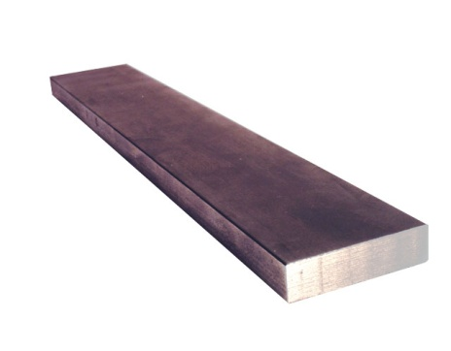

**Fig:4.1 Metal strip**

Specifications

Length: 50cm

Width: 5cm

Thickness: 4mm

Metal strip is narrow, thin stock that is usually 3/16 in. (4.76 mm) or less in thickness and under 24 in. (609.6 mm) in width. Metal strips are formed to precise thicknesses and/or width requirements.

**4.2 SOLAR PANEL**

The use of solar panels in this water pump system is essential for converting solar energy into electrical power to drive the pump. Photovoltaic (PV) cells in the panels absorb sunlight and generate direct current (DC) electricity. This electricity powers the pump's motor, with excess energy stored in a battery for use during low sunlight periods.the system eliminates the need for grid electricity or fossil fuels, providing a renewable, cost-effective, and sustainable solution for water pumping in remote and off-grid areas.

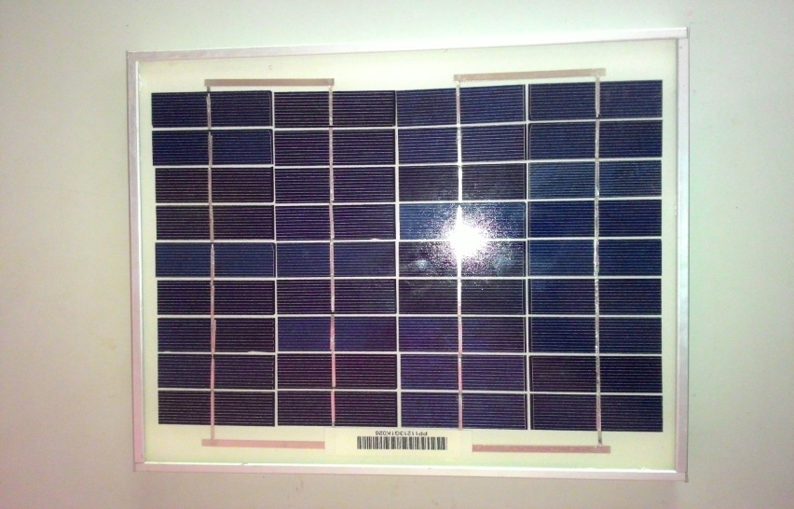

Figure 4.2 **Solar panel**

Specification

Power: 12V 3W.

**4.3 D.C MOTOR**

The electrical motor is an instrument, which converts electrical energy into mechanical energy. According to faraday’s law of Electromagnetic induction, when a current carrying conductor is placed in a magnetic field, it experiences a mechanical force whose direction is given by Fleming’s left hand rule.

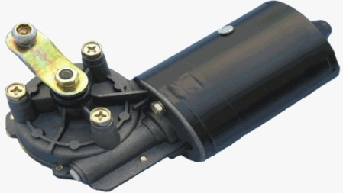

Figure 4.3 **D.C.Motor**

Constructional a dc generator and a dc motor are identical. The same dc machine can be used as a generator or as a motor. When a generator is in operation, it is driven mechanically and develops a voltage. The voltage is capable of sending current through the load resistance. While motor action a torque is developed.

The torque can produce mechanical rotation. Motors are classified as series wound, shunt wound motors.

**SPECIFICATION**

* DC Motor capacity : 12V
* Loading : 90rpm

**4.4 BATTERY**

The use of a battery in this solar water pump system is crucial for storing excess electricity generated by the solar panels during peak sunlight hours. This stored energy ensures that the pump can operate continuously, even during periods of low sunlight or at night. The battery helps maintain a stable and reliable power supply, optimizing the system's efficiency and extending the operational lifespan of the pump. By providing energy storage, the battery enhances the system's resilience and ensures consistent water access in remote and off-grid areas.



**Fig:4.4** Battery

**CONSTRUCTION:**

Inside a lead-acid battery, the positive and negative electrodes consist of a group of plates welded to a connecting strap. The plates are immersed in the electrolyte, consisting of 8 parts of water to 3 parts of concentrated sulfuric acid. Each plate is a grid or framework, made of a lead-antimony alloy. This construction enables the active material, which is lead oxide, to be pasted into the grid. In manufacture of the cell, a forming charge produces the positive and negative electrodes. In the forming process, the active material in the positive plate is changed to lead peroxide (pbo₂). The negative electrode is spongy lead (pb).

Automobile batteries are usually shipped dry from the manufacturer. The electrolyte is put in at the time of installation, and then the battery is charged to from the plates. With maintenance-free batteries, little or no water need be added in normal service. Some types are sealed, except for a pressure vent, without provision for adding water

**Battery Specification:**

Capacity: 12V and 7.3 Ah Rechargeable battery ,

Battery type: Lead – acid battery,

Charge capacity: 4.2 hour loading condition,

Charging time: 6 hours.

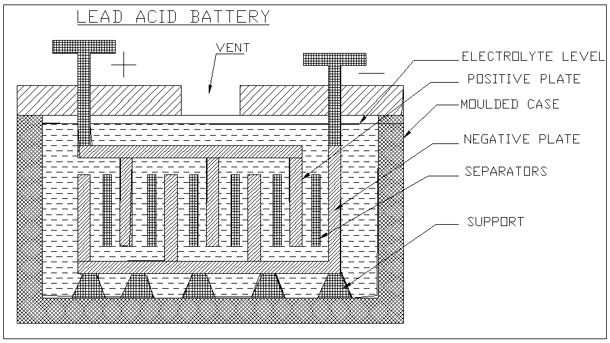

**4.5 SHAFT**

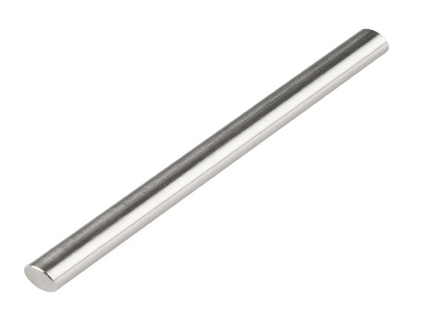

**Figure 4.5** Shaft

**Specifications**

Shaft diameter: 12mm

Material: mild steel

Length:26 inch

**Shaft**

Shaft is a common and important machine element. It is a rotating member, in general, has a circular cross-section and is used to transmit power. The shaft may be hollow or solid. The shaft is supported on bearings and it rotates a set of gears or pulleys for the purpose of power transmission.

**4.6 P.V.C. PIPE**

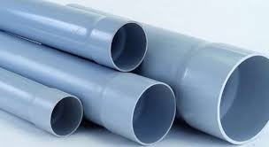

**Figure 4.6 P.V.C.Pipe**

we are going to use any light weight material with high mechanical strength. For the model we going to use PVC, . In real implement of the bladeless windmill the pole material should be such that it can withstand any atmospheric condition for long time. With this, the weight of the material should be as low as possible so it can easily oscillate due to force of the wind. It should also sustain tension and compression.

Plastic pipe is a tubular section, or hollow cylinder, made of [plastic](https://en.wikipedia.org/wiki/Plastic). It is usually, but not necessarily, of circular cross-section, used mainly to convey substances which can flow—liquids and gases (fluids), slurries, powders and masses of small solids. It can also be used for structural applications; hollow [pipes](https://en.wikipedia.org/wiki/Pipe_(fluid_conveyance)) are far stiffer per unit weight than solid members.

Plastic pipework is used for the conveyance of [drinking water](https://en.wikipedia.org/wiki/Drinking_water), [waste water](https://en.wikipedia.org/wiki/Wastewater), [chemicals](https://en.wikipedia.org/wiki/Chemical), heating fluid and [cooling fluids](https://en.wikipedia.org/wiki/Coolant), [foodstuffs](https://en.wikipedia.org/wiki/Foodstuff), ultra-pure liquids, [slurries](https://en.wikipedia.org/wiki/Slurry), [gases](https://en.wikipedia.org/wiki/Gas), [compressed air](https://en.wikipedia.org/wiki/Compressed_air), [irrigation](https://en.wikipedia.org/wiki/Irrigation), [plastic pressure pipe systems](https://en.wikipedia.org/wiki/Plastic_pressure_pipe_systems), and [vacuum system applications](https://en.wikipedia.org/wiki/Vacuum_system_application)

**4.7 BALL BEARING**

A ball bearing is a type of [rolling-element bearing](https://en.wikipedia.org/wiki/Rolling-element_bearing) that uses [balls](https://en.wikipedia.org/wiki/Ball_(bearing)) to maintain the separation between the [bearing](https://en.wikipedia.org/wiki/Bearing_(mechanical)) [races](https://en.wikipedia.org/wiki/Race_(bearing)).

The purpose of a ball bearing is to reduce rotational friction and support [radial](https://en.wikipedia.org/wiki/Radius) and [axial](https://en.wikipedia.org/wiki/Axis_of_rotation) loads.

**SPECIFICATION:**

INNER DIA :12mm

OUTER DIA : 37mm

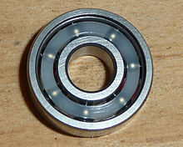

**Figure 4.7 Ball bearing**

**APPLICATION:**

In general, ball bearings are used in most applications that involve moving parts. Some of these applications have specific features and requirements:

* A [skateboard](https://en.wikipedia.org/wiki/Skateboard) wheel contains two bearings, which are subject to both axial and radial time-varying loads. Most commonly bearing 608-2Z is used (a deep groove ball bearing from series 60 with 8 mm bore diameter).
* Many [fidget spinner](https://en.wikipedia.org/wiki/Fidget_spinner) toys use multiple ball bearings to add weight, and to allow the toy to spin.

**4.8 DISC**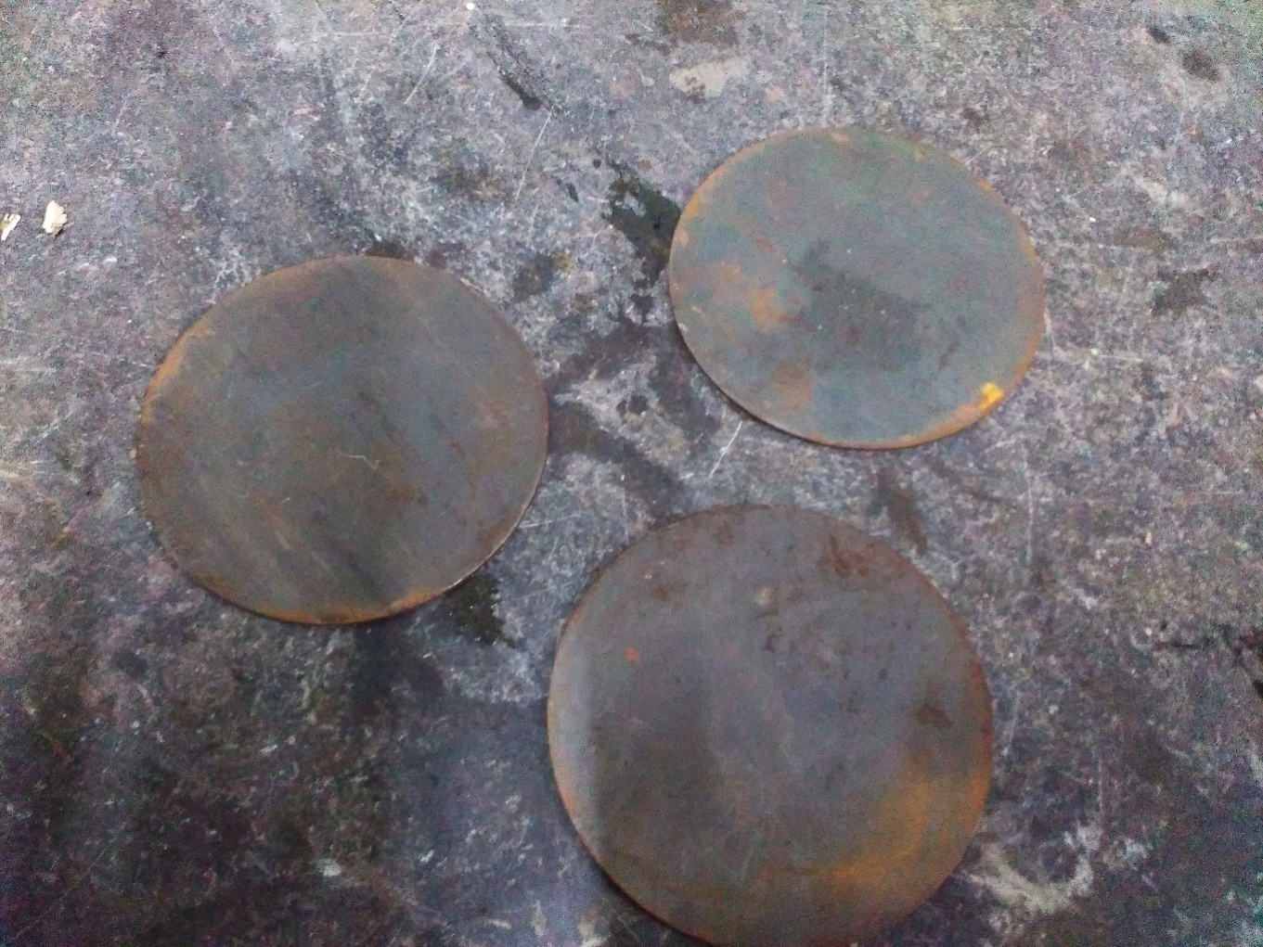

**Figure 4.8 Disc**

**Material: Mild steel**

**Outer diameter: 250mm**

**Thickness: 5mm**

In geometry, a **disc** is the region in a plane bounded by a circle. A disk is said to be closed if it contains the circle that constitutes its boundary.

The disk has circular symmetry.

**4.9 METAL FRAME**

The metal frame is generally made of **mild steel** bars for machining, suitable for lightly stressed components including studs, bolts, gears and shafts. It can be case-hardened to improve wear resistance. They are available in bright rounds, squares and flats, and hot rolled rounds

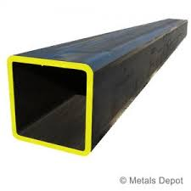

**Figure 4.9 Frame**

Suitable machining allowances should therefore be added when ordering. It does not contain any additions for enhancing mechanical or machining properties. Bright drawn mild steel is an improved quality material, free of scale, and has been cold worked (drawn or rolled) to size.

SPECIFICATION:

Dimensions: 3\4 square frame

Material: Mild steel.

**CHAPTER 5**

**WORKING PRINCIPLE**

The solar water pump system using bottle caps operates by converting solar energy into mechanical energy to pump water, leveraging several key components and processes. Photovoltaic (PV) panels capture solar energy, converting sunlight into direct current (DC) electricity. This electricity is stored in a battery unit, allowing the system to function during low sunlight periods or at night.The water pump, uniquely constructed from bottle caps and other recyclable materials, consists of an impeller formed from bottle caps that rotates when powered by a small electric motor. This rotation creates a centrifugal force, moving water through the pump housing and out through an outlet pipe.This innovative system not only improves water accessibility in rural and off-grid areas but also promotes environmental sustainability through the reuse of waste materials and reliance on renewable energy.

**2D LAYOUTS OF MODEL**

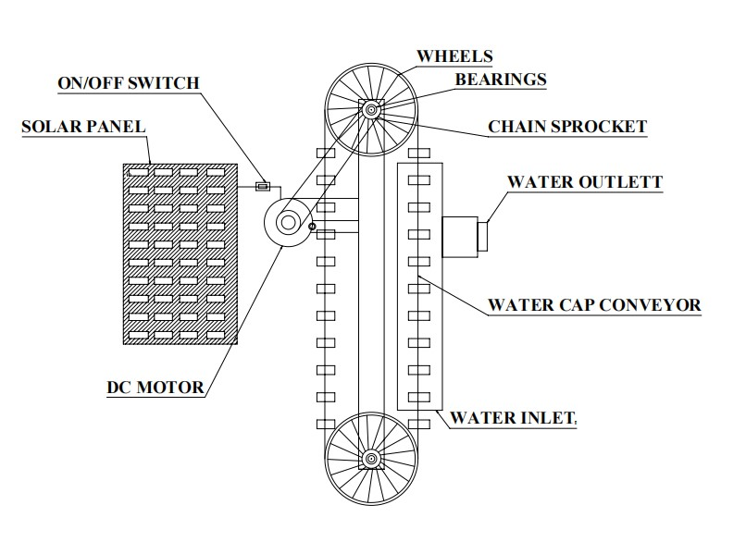

**Figure 5.1 2D Diagram CHAPTER 6**

**PHOTOGRAPHS**

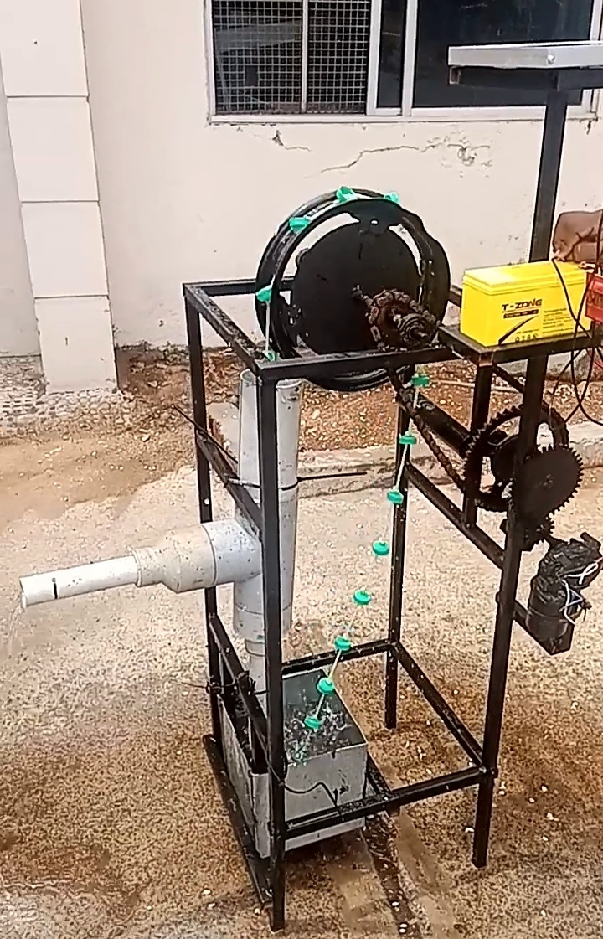 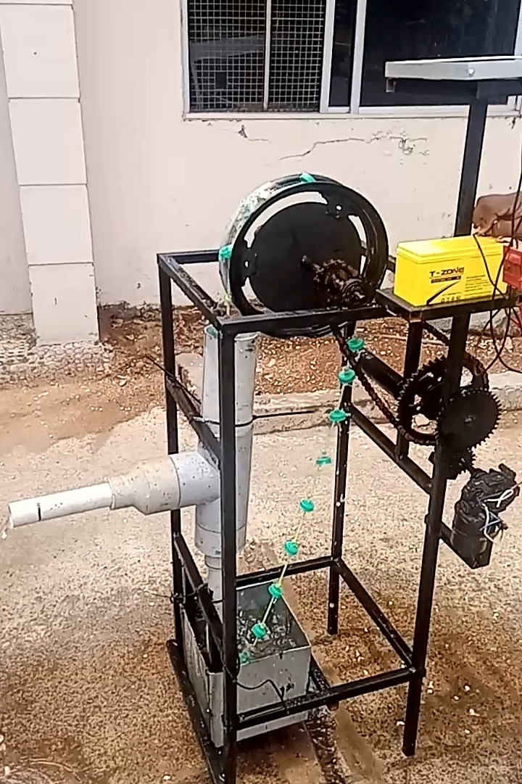

**Fig 6.1 Fig 6.2**

**CHAPTER 7**

**ADVANTAGES AND APPLICATIONS**

**ADVANTAGES:**

* Compactable water pumps offer portability,

making them ideal for diverse applications.

* Additionally, they enhance energy efficiency,
* reducing operational costs.

**DIS-ADVANTAGE:**

* Can’t able to run continuosly due to heating.
* Sharp things can able to cut the belt.

**APPLICATION:**

A compactable water pump can be used in various applications,

* agriculture for irrigation,
* residential water supply,
* construction sites,
* emergency situations for pumping water from flooded areas

**COST ESTIMATION**

**Table 7.1**

|  |  |  |
| --- | --- | --- |
| **SL.NO** | **DISCRIPTION** | **COST Rs:** |
| 1 | DC MOTOR | 800 |
| 2 | BATTERY | 800 |
| 3 | BEARING | 200 |
| 4 | FRAME | 900 |
| 5 | SHAFT | 200 |
| 6 | METAL STRIP | 200 |
| 7 | SOLAR PANNEL | 1000 |
| 8 | DISC | 600 |
| 9 | WHEEL RIM | 400 |
| 10 | PVC PIPE | 400 |
| 11 | TOTAL | 5500 |

**LABOUR COST**

LATHE, WELDING, GRINDING, POWER HACKSAW,

Cost = 1000/-

**TOTAL COST:**

Total cost = Material Cost + Labour cost

= Rs :5500+ 1000

Total cost for this project = Rs : 6500

**CHAPTER 8**

**CONCLUSION AND FUTURE SCOPE**

**CONCLUSION**

The solar-powered water pump system utilizing bottle caps offers a promising solution for enhancing water accessibility in rural and off-grid regions.By harnessing solar energy, the system reduces reliance on grid electricity and fossil fuels, lowering operational costs and carbon emissions. The innovative use of bottle caps for the pump promotes recycling and resource efficiency.Utilizing bottle caps for pump construction not only demonstrates a creative approach to resource utilization but also promotes environmental sustainability through recycling.The expected output of this project includes a consistent and dependable water pumping solution capable of operating in remote areas with limited infrastructure. The system is designed to significantly reduce operational costs, lower carbon emissions, and utilize readily available materials, making it both economically and environmentally beneficial. Additionally, the project aims to enhance agricultural productivity and improve the quality of life for rural communities by providing a reliable water source.

**FUTURE SCOPE**

The future scope for pump involves advancements into

1. efficiency,
2. smart technologies,
3. sustainability

**CHAPTER 9**

**REFERENCE**

1. Omar Barden, Wind turbine Utilization for water pumping. in Jordan Published in 2003
2. MisrakGirma, AbebayehuAssefa. Feasibility study of a wind power water pumping system. Published on 8th December 2015
3. ArlosD’alexandriaBruni, VanioVicentresantos de souza, Comparative study between a savonius rotor made on two or three blade. Published on 6th November 2013
4. Ronak D Gandhi, PramodKothmir, Design and development of windmill operated water pump. Published in December 2015
5. G. M. Bragg, W. L. Schmidt. Performance matching and optimization of wind powered water pump. Published on 18th July 1978
6. Juan Enciso, Rio Grande Basin Initiative of the corporative state research, education, an extension service, United States Department of Agriculture under Agreement no. 2001-45049-00249